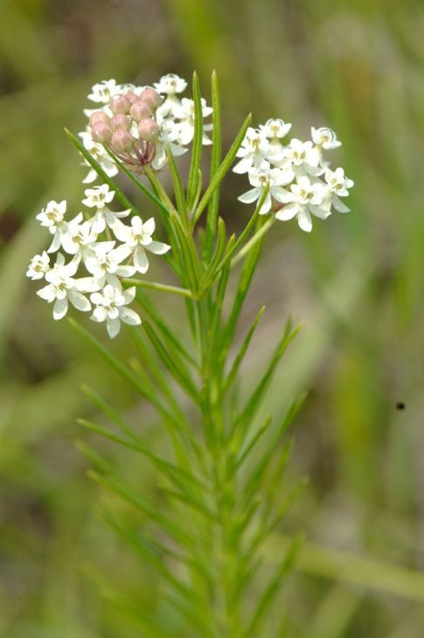
Whorled Milkweed . Asclepias verticillata

*Host plant for monarchs *1ft-3ft tall *Drought tolerant
*Deer resistant/toxic to livestock
*Attracts a wide variety of insects
*Blooms later than other milkweed species

